PRESS RELEASE
For Immediate Release

Celebrating History Through Culinary at 1928
The 1928 is a new restaurant in town that will take diners to experience a bygone era through its tantalizing culinary.
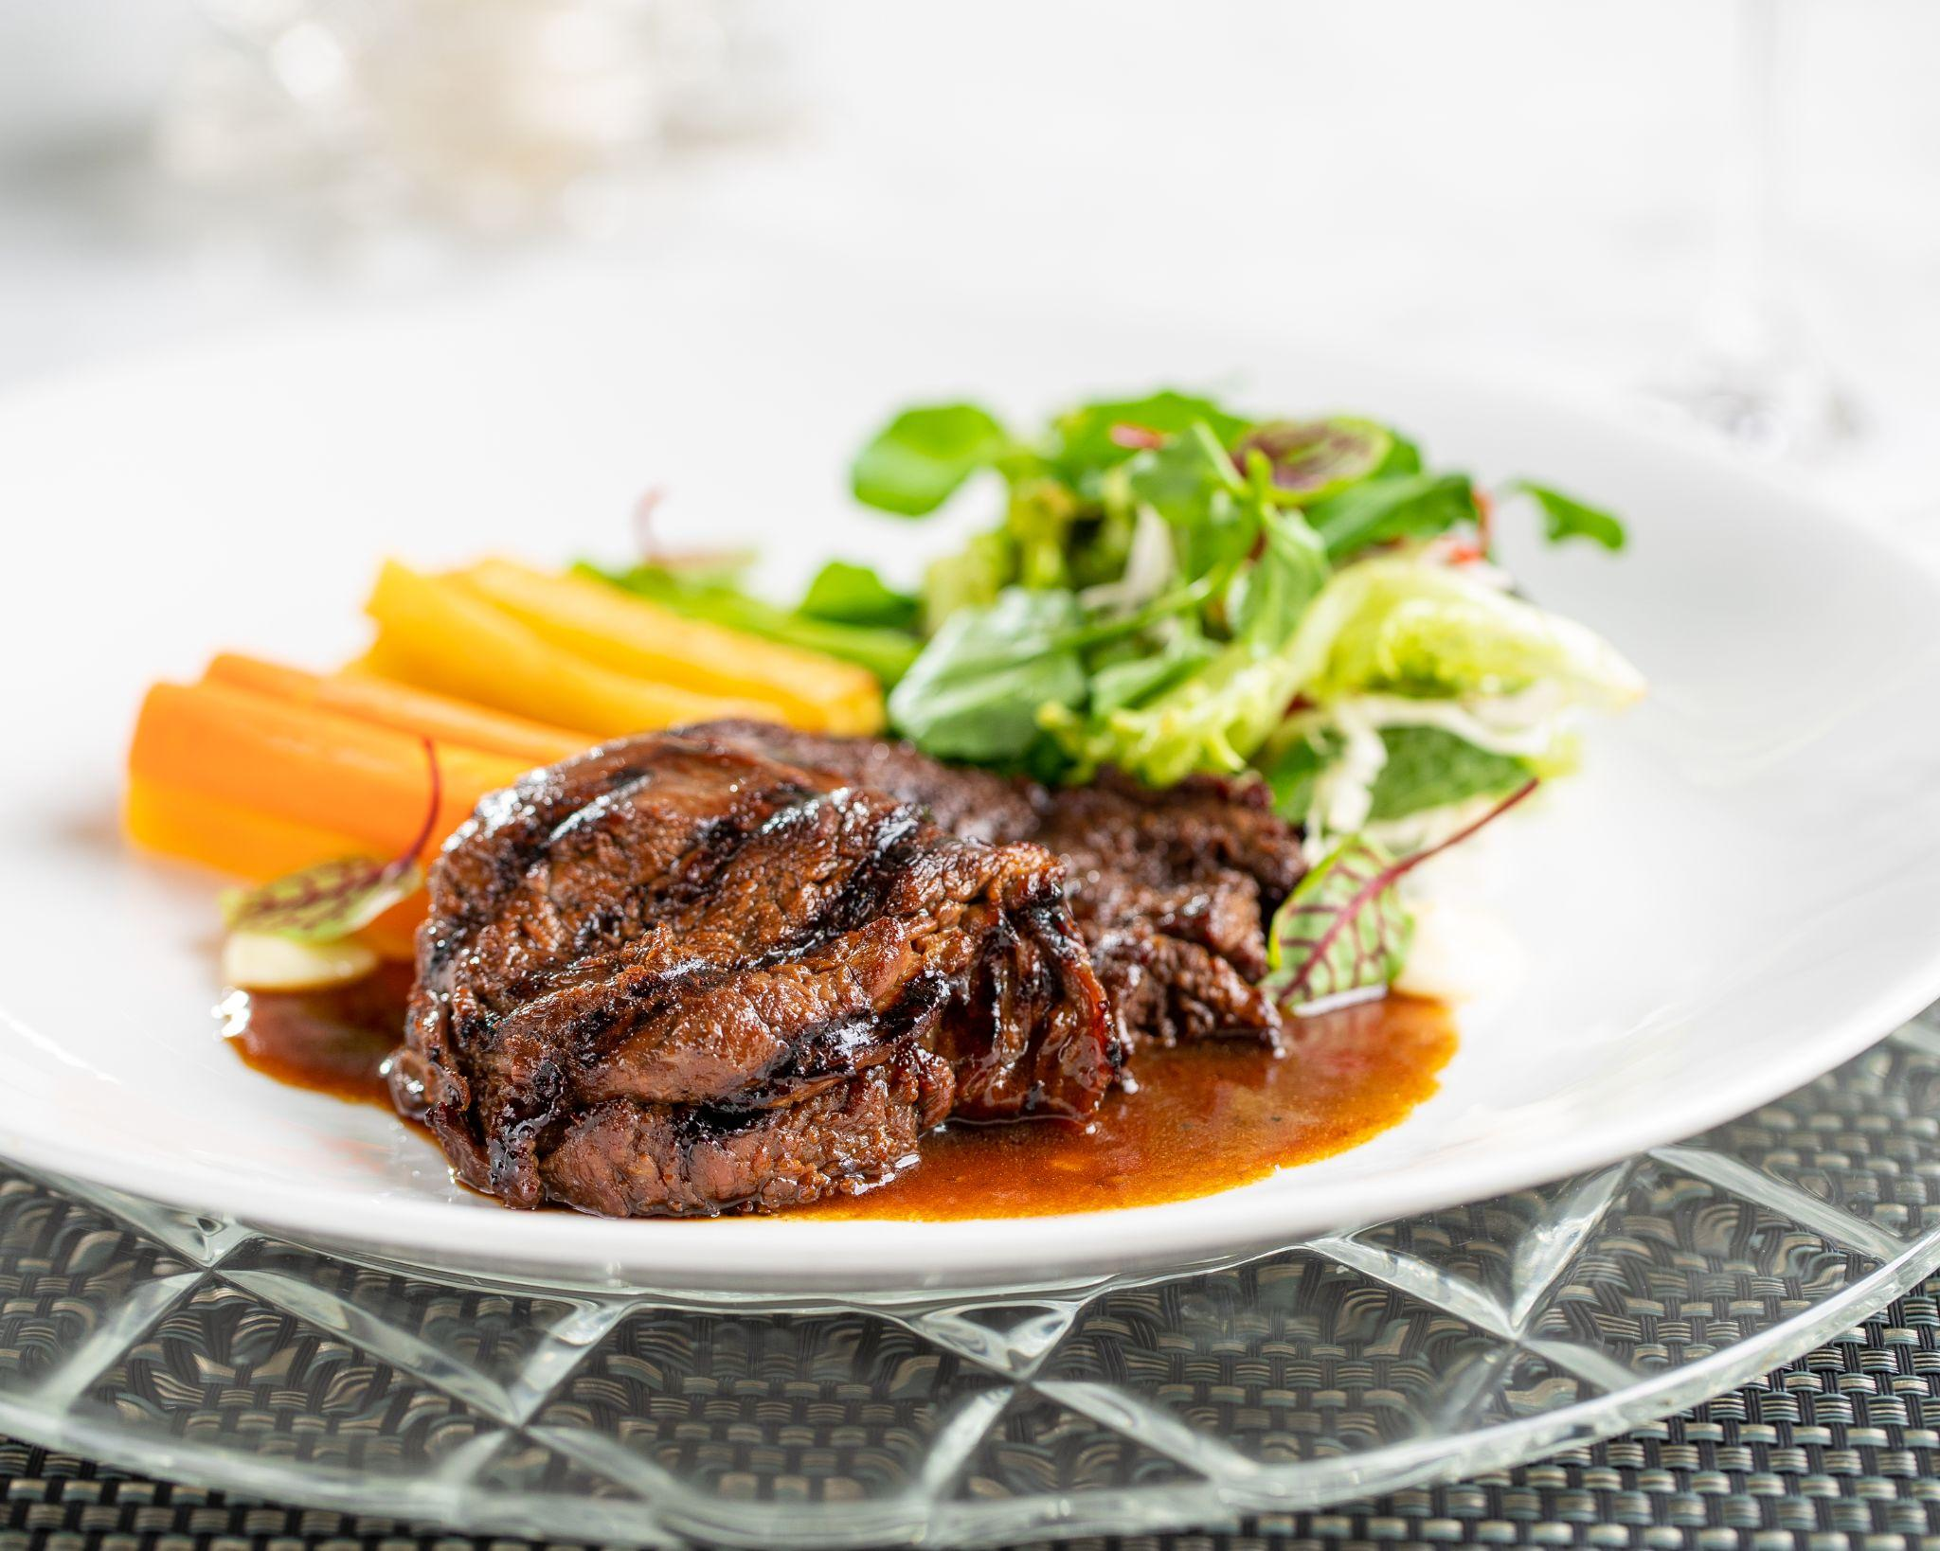
Jakarta, February 2022. Celebrating the colonial history of its building, The Hermitage, a Tribute Portfolio Hotel, Jakarta proudly introduces 1928, a new restaurant that is driven by the heritage building concept. Occupying the area that was previously L’Avenue Restaurant, 1928 will serve an interesting menu that focuses on colonial, Peranakan, and Indonesian/Pan Asian cuisine.

The 1928 will introduce a fresh, modern take on the colonial era dishes using the best locally sourced ingredients. Ferdian Tobing, Executive Chef at The Hermitage, a Tribute Portfolio Hotel, Jakarta has come up with a series of the mouthwatering menu for diners to try. “The menu is designed to evoke memories of the old times but without losing the modern touch,” explains Chef Tobing. The menu features worth-to-try signature dishes such as Grilled Bone Marrow, Bruine Bonen Soep, Macaroni Schotel, Beef Bitterballen, Pindang Bandeng, Dutch Steak, Klappertaart, and Poffertjes.

Brand New Position
With renowned shopping, dining, and entertainment, Jakarta is simply one of the most vibrant cities in the world, and The Hermitage, a Tribute Portfolio Hotel, Jakarta is thrilled to share the unique concept with both residents of and visitors to this amazing city. The 1928 is the latest colonial-style eatery to open in Jakarta and offers diners the chance to revisit history through an array of food and beverages available. “The launching of 1928 is to position the hotel as a culinary destination highlighting the heritage cuisine and unique offerings,” says Harry Suryadharma, General Manager of the hotel. Besides 1928, The Hermitage, a Tribute Portfolio Hotel, Jakarta is also home to La Vue, a rooftop bar with a gorgeous view of Jakarta.

A Culinary Experience with A Twist
The 1928 offers a la carte menu with Rijstaffel Package as the best way to have the most culinary experience. With this package, diners can taste a bit of everything from the restaurant's signature dishes for a minimum of four persons. This package is a perfect option for family, friends, or clients' intimate gathering.

The 1928 will also introduce “1928 Sunday Brunch” that will happen every Sunday between 12 pm to 3 pm. The brunch will feature an array of all-you-can-eat colonial, Peranakan, and Indonesian/Pan Asian cuisine with delicious entrees, mains, desserts as well as a la minute delights prepared by Executive Chef Ferdian Tobing. The brunch will also feature a drink trolley with a bartender roaming the restaurant to concoct mocktails.

- End -

About The Hermitage
The Hermitage, a Tribute Portfolio Hotel, Jakarta is located in the heart of Jakarta's most prestigious district, Jl. Cilacap No. 1. The 1920’s art deco building comprises 90 rooms and suite, 3 restaurants, and 350 sqm of meeting rooms. A member of Marriott International’s Tribute Portfolio, guests of The Hermitage can take advantage of all the perks of the Marriott BonvoyÔ global travel program and earn and redeem points during their stays. More information can be found at www.hermitagejakarta.com and by following the property on Facebook and Instagram.

About Tribute Portfolio
Tribute Portfolio is a growing global family of characterful, independent hotels drawn together by their passion for captivating design and their drive to create vibrant social scenes for guests and locals alike. With nearly 50 hotels open around the world, Tribute Portfolio has struck a chord with those who seek out independent experiences and crave a connection with the community when traveling. From boutique resorts like Inn at Rancho Santa Fe in California and urban hotels such as The Vagabond Club in Singapore; to hotels in indie-spirited locales like Noelle in Nashville and The Slaak in Rotterdam, each Tribute Portfolio hotel celebrates its individuality, offering travelers a fresh, often colorful, perspective. Stay with character and stay connected on Instagram, Twitter and Facebook. Tribute Portfolio is proud to participate in Marriott BonvoyÔ, the global travel program from Marriott International.

The program offers members an extraordinary portfolio of global brands, exclusive experiences on Marriott Bonvoy Moments and unparalleled benefits including free nights and Elite status recognition. To enroll for free or for more information about the program, visit MarriottBonvoy.marriott.com.

MEDIA CONTACT
Dequinita Vadela
Marketing Communications Manager
The Hermitage, a Tribute Portfolio Hotel, Jakarta
M. +62 817-0953-646
E. dequinita.vadela@marriott.com

